**Unit 17.1 Investigation of mobile apps by Husnain Ahmed.**

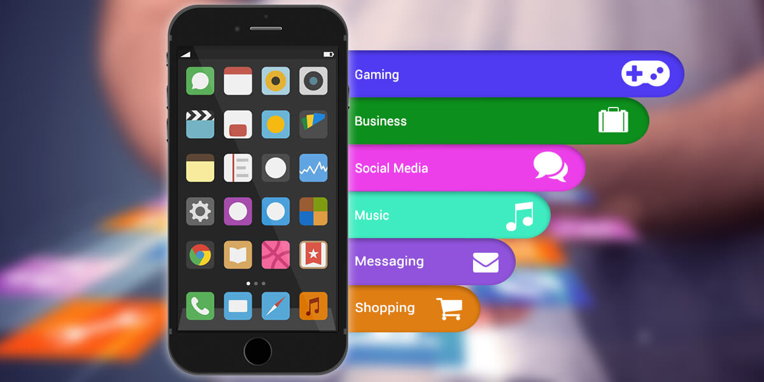

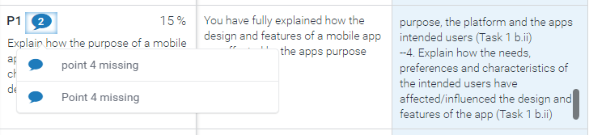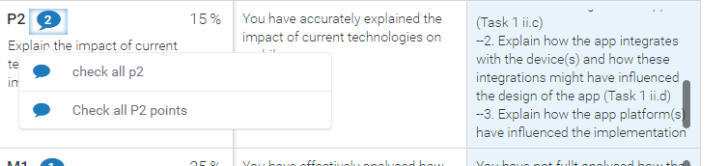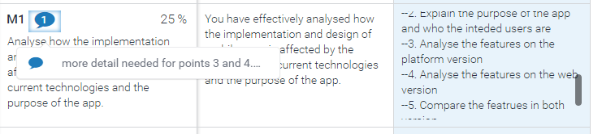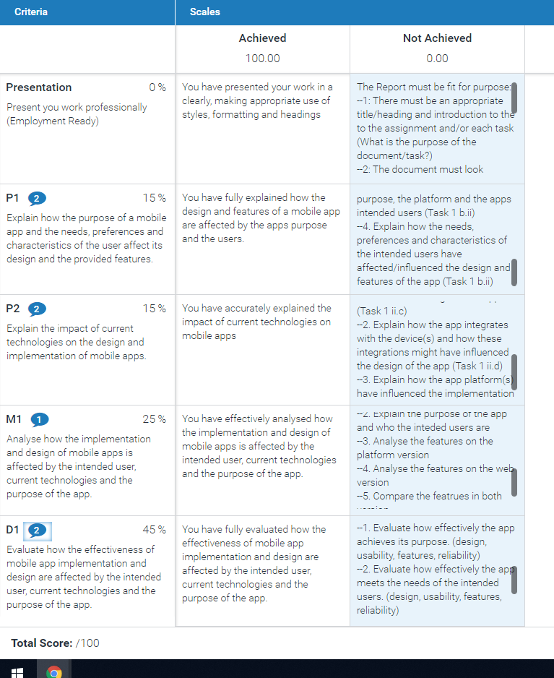

**Investigate Mobile Apps**

# Task 1: Investigation of Mobile Apps

The 2 apps I have chosen to investigate are the native to android app ‘Notes’ and a hybrid app that is on android, apple and the web browser called ‘WhatsApp’. I will investigate their purpose, target audience, functions and how the design has been influenced.

**Notes**

‘Notes’ is a free app on the google play store for android devices, it is a minimalistic notepad taking app that has only 2 functions, to create text documents and have them easily accessible to view/edit at a single tap. The black and white colour scheme and default simplistic font creates a very clean and professional aesthetic that is not too distracting and is easy on the eyes.

In the top right there is a ‘+’ icon to create new notes or ‘memos’ and the whole screen is filled with buttons that have the name of the text documents on them and when clicked on they open the text document. These icons are also very simplistic, easy to understand and give the app a high level of usability.

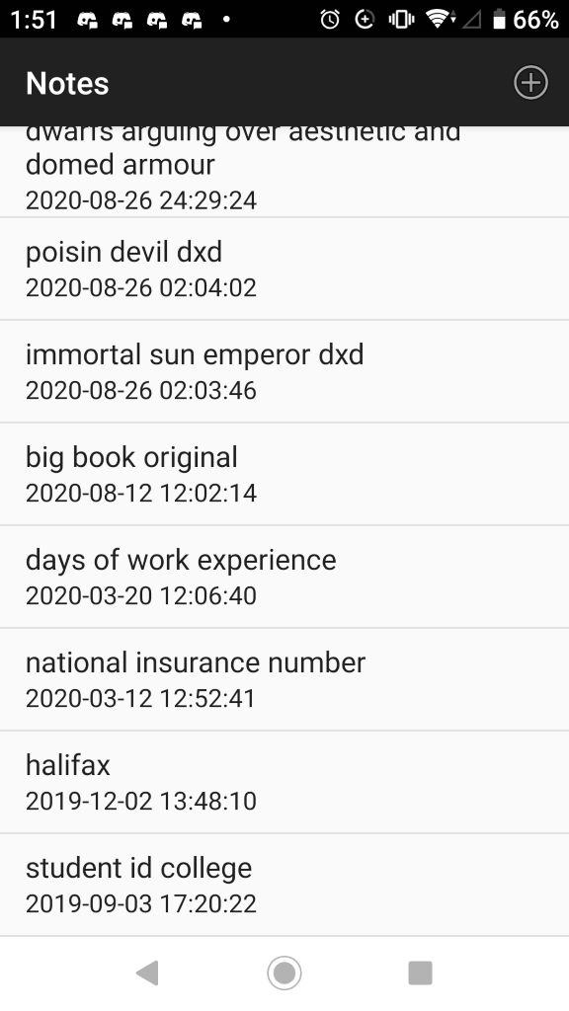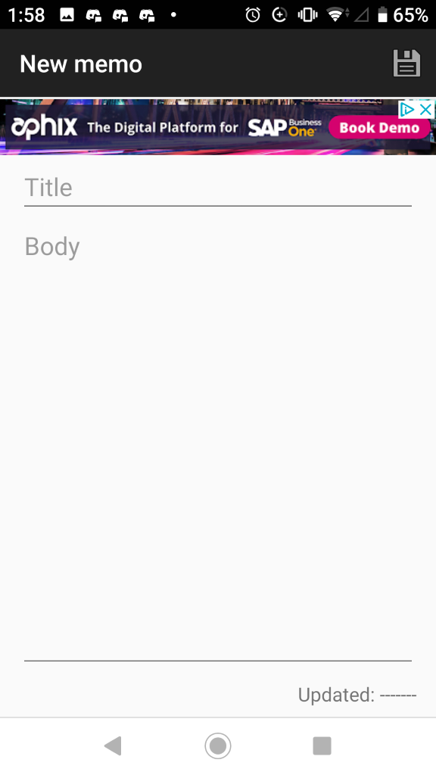

The buttons as you can see have the name of the document that they are attached to and the date that it was last edited.

The intended audience is anyone that needs to take notes, so it is very easy to use and reduces the learning curve. This app does not need a tutorial due to the lack of functions it has, but it is not intended to have multiple functions; it is just a single function that is done well.

The app makes use of the touch screen and on-screen keyboard to navigate between text files and edit them. It also keeps track of when you last edited a file underneath the file name.

If I were to code this from scratch, I would use windows forms to create the buttons, ui and use c# for the back-end code that creates, accesses and edits text documents.

I believe that this app could be improved by making it a widget, this is so that it can be accessed more easily from the homepage and increase productivity.

The users' needs for a note pad app are very simple and this is reflected in the design. There are no distracting features or designs as the sole purpose of the app is to take notes. The app has all the needed features that are needed for a notepad and nothing extra.

As this app is aimed at a rather wide audience, it is important to not be designed to cater to one individual target audience needs such as a heavily cartoony GUI for children. I believe that this simple and sleek design caters to all potential audiences needs and it is not too much of a distraction from the original purpose of the app.

As this app is integrated specifically on the android device it has been designed to be in a portrait mode and not a landscape without the option of rotation, this gives the feel of reading a book or a piece of paper and comes off as more professional that landscape would. It is perfectly integrated with android devices due to this fact and is optimised for these devices using the touch screen, the on-screen keyboard and saving onto local storage.

The implementation of this app is properly optimised for then android devices, specifically mobile phones instead of tablets, but it would work fine on tablets. It is used to take notes of little things every day and as such is better to be used on the go, most people carry around a mobile phone with them instead of a pen and notepad, so this is more convenient for them.

**WhatsApp**

WhatsApp is a social media app for messages and calls, you can send all kinds of media to someone directly or in a group chat with multiple people involved as recipients.

This is not a native app, it is hybrid as it is on virtually all platforms, android, iOS, windows and the web.

There is a wide range of intended audience that this app targets as it is primarily used for communication between people. According to Experian marketing services ‘71% of users are in the age bracket of 18-44' this is the age of most users of WhatsApp and it caters mainly to their needs rather than children’s, with its lack of games.

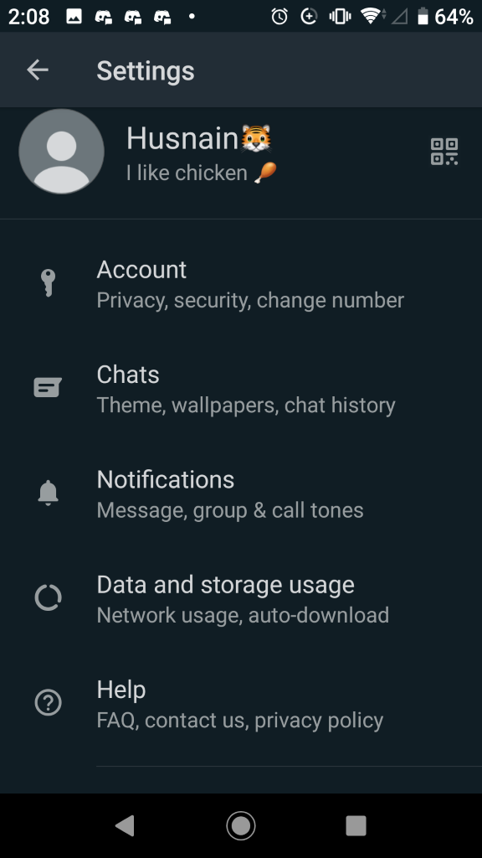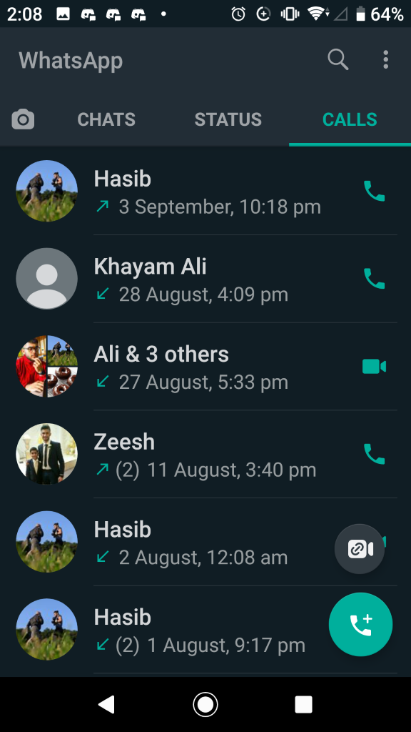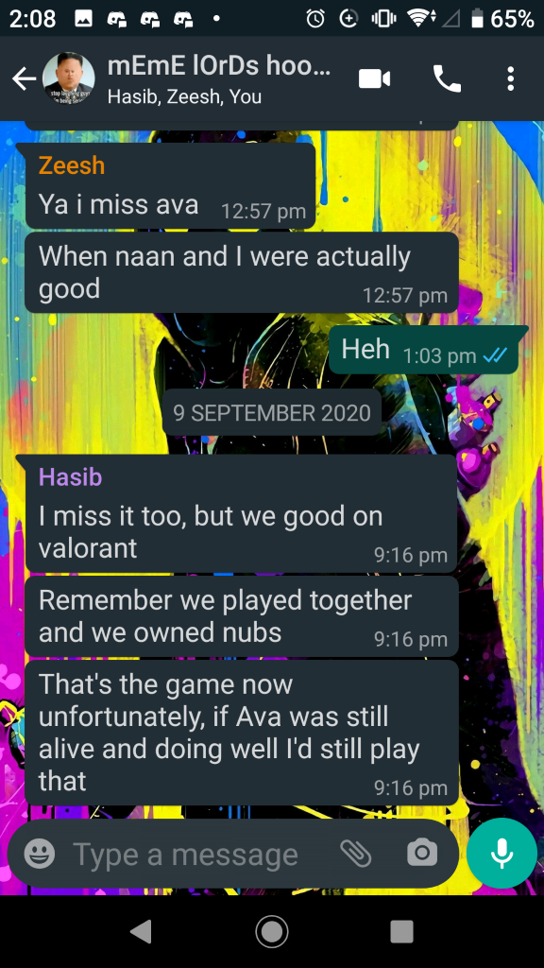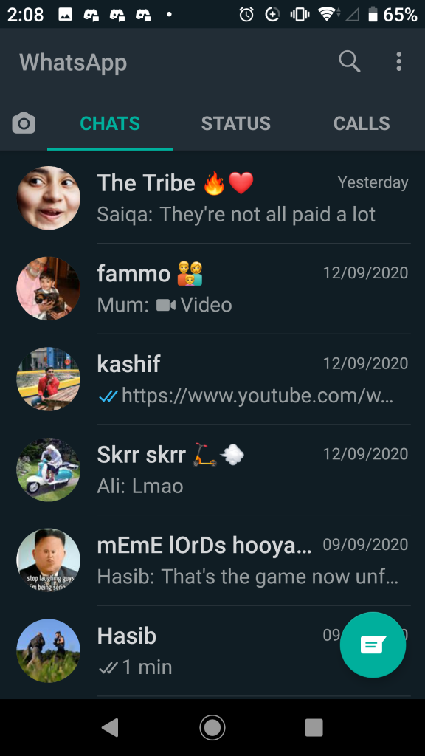

However, it is a superb form of communication only needing an internet connection, whether that be data or wi-fi, to send messages, media, links or calls. It is often used as an alternative to regular rexts or calls as it does not use up money since sending messages over Wi-Fi is completely free.

There is also a status function where you can upload images and videos that disappear after 24 hours.

The mobile version of this app has been influenced to be primarily portrait mode but can be rotated sideways to be in landscape mode for devices such as iPad’s and tablets. It has also been integrated into the device properly through using different speakers for calls as the mobile app can use both the regular loudspeaker and the small speaker at the top of the phone for private calls. It also uses the native emojis of the device or keyboard app as opposed to the stock WhatsApp emojis used on the web application.

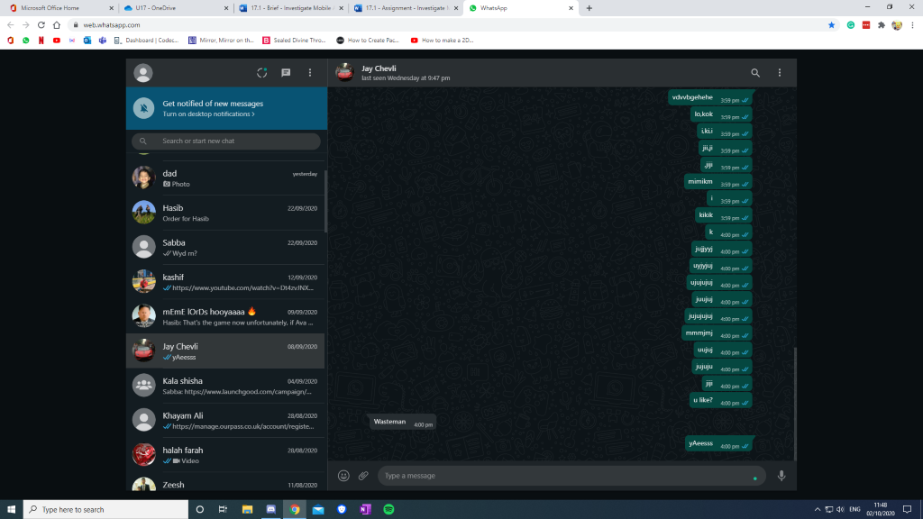

This is the web version of WhatsApp, this is optimised for the website on computers and laptops, as such it is in landscape mode by default. Different from the mobile app the selection of chat logs and the messaging itself is side by side on your screen as opposed to only one being on your screen at any time, this is because of the increased amount of room on your larger display compared to a mobile device, this shows how it is integrated into the web for computers and laptops. This does not however, have access to voice and video calls. Because of this it is only used as a messaging platform as best for convenience and is inferior to the mobile version of the app.

The users' needs for a social media app such as WhatsApp are very broad as it has multiple functions. This is reflected in the design. There many features such as separate sections for message logs and call logs, status and a settings page. This caters to the users' needs to be able to communicate with people and even customise the app and their own profile name and profile picture. As the messaging and call functions are each a very substantial and important part of the app, they have their own screens and do not overlap.

As this app is aimed at a rather wide audience, as everybody can use a social media used to communicate between individuals and groups to talk to friends and family. As such it is not designed to cater to one audience needs and is instead very broadly designed, with a basic white background and green message icons, there is also a dark mode function and even a custom background option to allow users to customise their messaging experience. This degree of freedom with the appearance of the app allows it to cater to all audiences.

If this was targeted at a specific target audience such as businessmen, it would be vastly different as it would be simpler and sleeker as there is no need for things such as profile pictures and status’. In this case the app would be used solely for communications with calls and messages, removing the unneeded features such as customisation and status.

However, WhatsApp has a broad audience and caters to everyone by having a lightweight design that feels native to the device and not like a badly ported app designed an older device the features are fairly self-explanatory so they require little to no instruction on how to use them.

This lightweight and highly customisable design has been brought about in response to the users that come from all walks of life and all kinds of backgrounds, these users can freely change their WhatsApp gui.

# Task 2: Analyse and Evaluate a Range of Mobile Apps

The 2 multi-platform apps I have chosen to investigate are ‘Instagram’ and ‘YouTube’.

**Instagram**

# Instagram is a free media sharing app that is available on android, iOS and the web. It is mainly visual with the only text being in the captions of your posts (not including private messaging). It allows images in a 1:1 square ratio and videos up to 1 minute long.

The intended audience is the younger generation as majority of the users are in between the ages of 18 and 29.

According to Piper Jaffray's 2019 Taking Stock with Teens consumer insights survey, 85% of teens say Instagram is their preferred social network (followed shortly by Snapchat). - <https://blog.hootsuite.com/instagram-demographics/>

This shows that it is very popular with the younger generation both as a way to communicate to their friends and family and keep up to date with occurrences and news around the world, down to silly things like watching cat videos.

**Analysis**

The mobile version of Instagram has many functions such as: liking someone’s posts which is kept track of by a score counter directly under the post. Saving them to an archive for later viewing, which can be used to look back on some amazing posts that you want to see another time without having to screenshot or screen record them. Commenting on other people's posts so that they can know your thoughts on them. Sharing them to others via dm’s so they can see them and laugh along with you. A private messaging function called DM’s for both 1 on 1 chats or group chats with multiple participants up to a maximum of 50 people. 24-hour stories which are short videos or images that can only be seen for an entire day before disappearing, this is used to show what you have been doing recently such as your daily occurrences or going to a festival or theme park or even on a walk. Searching for other users by their usernames to find their page and their posts, You can also search for hashtags, these are a grouping method that groups together all posts under the same hashtag together, for example #cat would show you cat videos. Following users to get to see their posts on your home page or blocking them so that they cannot interact with you or see your posts if they have offended you or you just do not like them for any reason. There is also a new livestreaming feature that is called “IGTV”. IGTV is also a standalone app that allows for much longer videos than Instagram's 1 minute clips, basic functionality can be found through the Instagram app. Such as watching some longer videos and clicking on links to sites related to these videos.

‘Mobile devices allow uploads of up to 15 minutes in length with a file size of up to 650 MB, while desktop web browsers allow uploads of up to 60 minutes in length with a file size of up to 3.6 GB’ - <https://en.wikipedia.org/wiki/IGTV>

IGTV on mobile allows for medium length clips that can explain in some detail about the post or a topic such as animal welfare or charity. IGTV on desktop through the web can upload much longer videos that can explain in depth on some topics, in this aspect the website is superior to the mobile app.

The mobile app uses the touch screen of your mobile device (phone or tablet) to navigate between the different features and screens via tapping and swiping. It uses both your devices front and rear facing cameras to take pictures and videos, it also uses the microphone for sound in videos or to send voice messages on direct messaging. It uses the loudspeakers for outputting sounds from both videos and voice messages.

There is also a web version of Instagram, however it is limited as the app was designed and optimised for mobile use. Accessing the Instagram website from your phone is almost the same as using the app except for the pop-up that would redirect you to the official Instagram download on either google play or apple store depending on whether you are browsing from an android or iOS device (this pop up does not show on desktop computers and laptops).

The main difference between the web and mobile phone versions of the app are the fact that on the web version you cannot upload and take images via the camera (or webcam). The mobile version also allows you to zoom into a post by pinching the screen. The Desktop version cannot upload posts unless you are using google chrome, which is a hindrance to your social media experience. The desktop version also allows you to view peoples posts and profiles without logging in to an account as long as they (the poster) have a public profile (private profiles require you to follow them to see their posts and stories) while the mobile app doesn’t, it needs you to log into an account to use the app. Desktops also don’t have autocorrect like mobile does unless you have installed a google chrome extension such as Grammarly or some other third-party software to fix your spelling and grammatical mistakes.

As the Desktop version is on a bigger screen the photos are also bigger and they appear to look better than on a small phone screen, this does not mean that they are of higher quality, if the screen quality on your computer and phone are the same (generally most are 1920x1080 max) the quality will be the same but due to the photos larger size it is much more aesthetically pleasing than a miniature version.

It is also much harder to accidentally like or click on something on the desktop compared to on mobile as clicking the mouse twice requires more effort compared to double tapping the touchscreen.

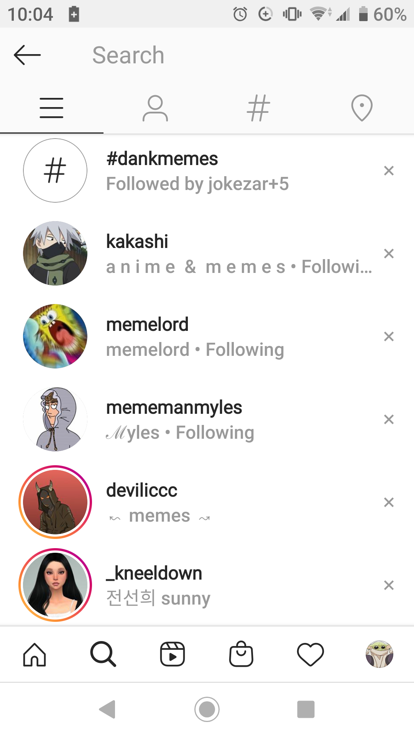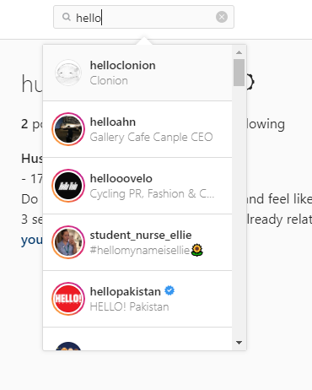

The search function of the app on both mobile and website is very good and works superbly, the only notable difference is that the mobile app remembers your most recently searched things and keeps them there unless you delete them. The mobile app also has 3 specific searching columns for accounts, hashtags and places (geo-tagged locations). The website on the other hand only has a general search option for users and can search for hashtags if you use the symbol, for example searching “#meme” for memes.

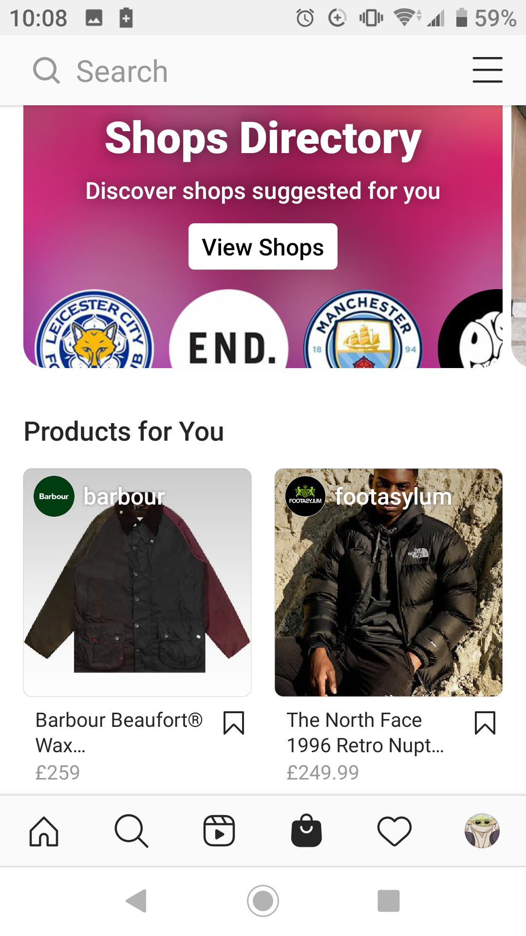

A feature unique to the mobile version of Instagram is the shop icon in the navigation bar, this shows products and shops that Instagram thinks you would like based off your search history.

You can also find a ‘view shop’ button on the profile page of shops accounts. This feature is fairly new, coming out in May of 2020 due to covid 19 in an attempt to help people with online shopping.

Some positive points of Instagram are the high privacy it gives and as it is a highly visual platform, primarily dealing with photos this is very good as you may not want everyone to see some of your private photos of you or your family.

Another pro of the app is that it is very good for people who like to travel as it has a geo tagging feature where you can point out where on the map a photo was taken and so people can see photos of famous places and landmarks.

A negative point of Instagram is the fact that you must follow people to see their posts if their profile is on private, this however, could be seen as a good point as it increases security.

Another negative point is that it can be a detriment to your mental health as people may obsess over the number of likes that they get, and they may get mean comments on their posts that hurt their feelings.

A downside to this app is the overwhelming amount of advertisements that plague the platform and interrupt your viewing experience.

Some more problems are the inadequate tech support and the fact that privacy settings cannot be applied to individual posts and only to your profile as a whole so they apply to all of your posts.

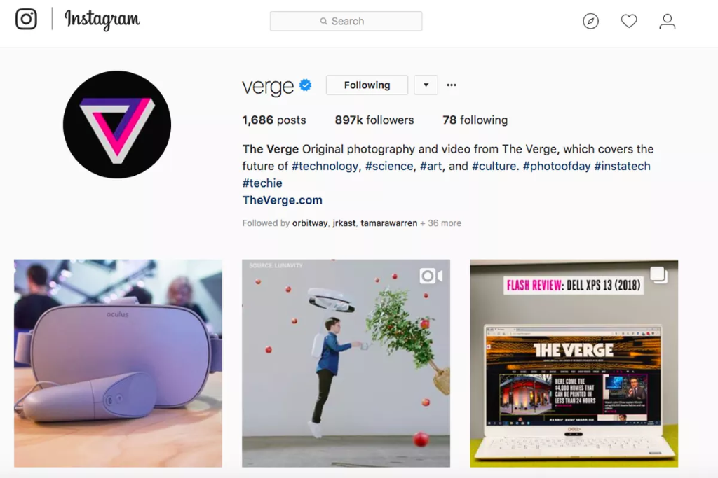

In my opinion I believe that the mobile version of Instagram is much better than the website version as it is the intended platform that it was created for and it is optimised for it with much more features. There is no empty space on the screen with the mobile app while the website version has a ton of it that is unused for anything. The only real advantages of Instagram web is the ability to pause videos by clicking on them and the larger image size, other than that it is much worse that the app in almost every regard and is missing out on many features.

**Evaluation**

# Overall Instagram is a very good app that makes use of its features very well and does its purpose. As it is primarily a mobile app the website takes after the app for most of its design as well as taking a 16:9 resolution with blank bars on the sides of the screen. It has a nice design that is minimalistic and not too eye-catching with vibrant colours and doesn’t distract from the whole experience of using social media to view posts, news and your interests. The app is very reliable as it is quite popular and has moderators and a dedicated customer support team constantly working on making the app the best it can be and trying to sort out issues within the community. The usability of the app is of such a high level that even users that are newly joined and not the most tech inclined people. One of the features is the app automatically finding related content to things you like and recommending them to you on your ‘explore’ page.

# It effectively meets the needs of its users by having an easy to navigate layout and design that is easy to comprehend and use. A good change would be if the website had the same features as the mobile app and uploading was easier, as you currently can't upload to the website from anything but google chrome. The app has a high level of usability as the icons are very easy to understand such as an icon of a house for the ‘home’ page and an icon of a magnifying glass for the searching function called the ‘explore’ page. The clear and concise design makes it very easy for new users and even old users who are coming back to the app to understand all the features. It is also very reliable as it can verify official profile from famous people to show you that they are not fake. One of the features that I think could be improved on the website version would be utilisation of the entire screen space instead of just leaving it empty, potentially filling that space with recommended hashtags that you could like or even with tooltips and advice about the app.

It effectively makes use of the technology on hand on all versions of the app by using the touchscreen to navigate through the app with swipes and taps. It also makes use of the microphone and camera built into your phone for pictures and videos. Instagram's highest resolution is currently 1920x1080, this means that it does not allow 4k quality pictures and videos. It has a database which it used to archive your ‘saved’ posts for later viewing, this makes use of cloud storage as does most of the app as all its content is stored on the cloud to be accessed.

**YouTube**

# YouTube is a free video sharing and livestreaming platform that can hold up to 24-hour videos of all qualities and ratios, it is available on all platforms including but not limited to android, iOS, windows phone, web, Xbox, PlayStation and smart tv.

The target audience is any and all people as there is content available for people of all ages, some videos that show mature content are age restricted to accounts that show you are 10 or over, there is also another app called YouTube kids that only shows child friendly content with no depicted gore and swears.

Now that YouTube is a decade old it has quite a broad reach over a multitude of different people and is used by all kinds of people unrestricted to race or age. However, millennials do watch more YouTube than the older generation.

As with all social media there is still a chance that you may see something unsatisfactory that offends you or you do not deem appropriate for viewing, in which case you can flag the video and file a report.

**Analysis**

Some of the functions that YouTube has on all platforms are: uploading videos/livestreams, so that others can watch and enjoy them. Viewing videos/livestreams, to enjoy. Searching for content such as playlists and channels, subscribing to these channels and following other users so that you are notified when they upload any videos. It is also possible to like/dislike and comment on videos to tell others your opinions on them and to share the videos with others via other social media so that they can also enjoy them. An uncommon type of content that came out a while ago on YouTube is 360 degrees videos that are meant to be watched with a VR headset, these can grant an immersive feel to make the viewer actually feel like they are in the scene that is being portrayed.

A mobile exclusive function is the ability to download videos onto your device for offline use, this helps with viewing videos on the go without an internet connection. It uses the touch screen to navigate it and the on-screen keyboard to type as phones do not have an attached keyboard and mouse. The mobile app also has the exclusive feature of push notifications to notify subscribers, but most people opt out of these by turning them off.

The mobile app is navigated by swiping up and down to scroll past videos that are recommended to you on your home page and by tapping on what videos you would like to watch. There are different pages that can be accessed from the navigation bar at the bottom of the screen such as your subscriptions, notifications and history. And finally, at the top of your screen there is a search bar that pulls up an on-screen keyboard once tapped on and can be used to search for content.

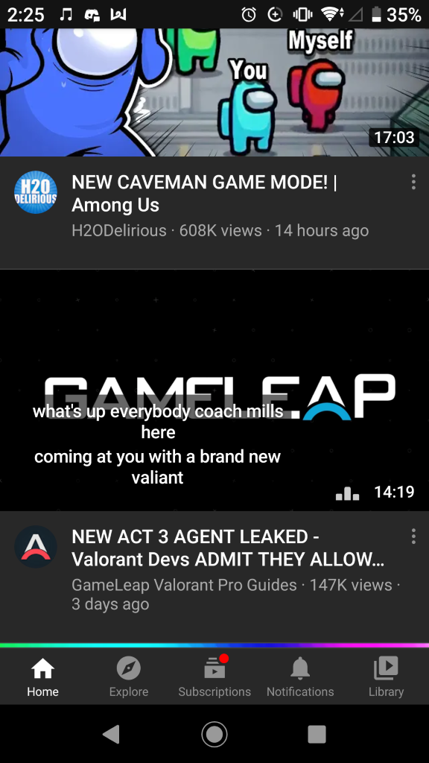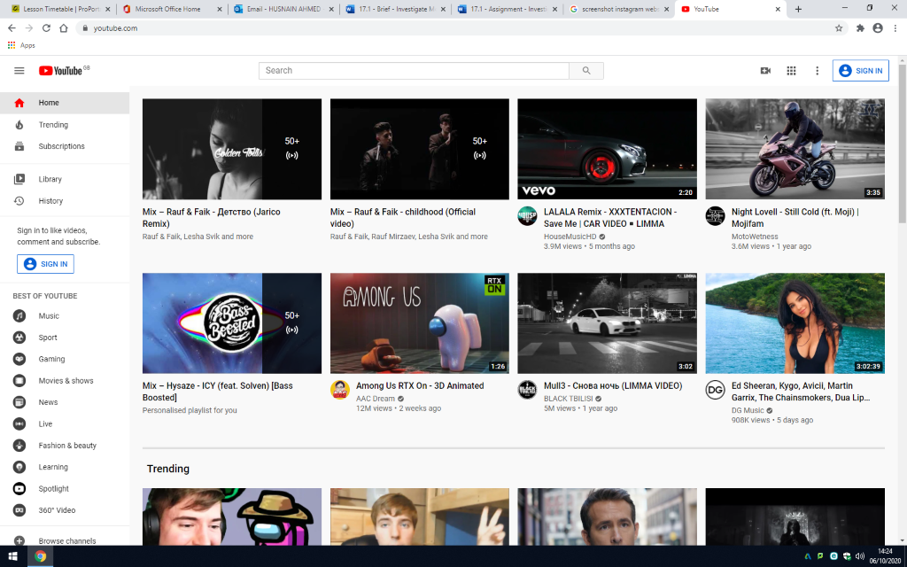

The design layout differs for both mobile and pc versions of the app. The mobile version is in portrait mode by default whilst the website is landscape due to the orientation of most smart phones being different to the landscape monitors of computers and laptops. However, the mobile version can be rotated to landscape if you wish so.

The website has a navigation bar on the left side whilst the mobile app has it on another screen that can be navigated from the icons at the bottom.

A cool new feature that has recently been added to all versions of YouTube is video chapters. This works by segmenting the video into different sections using timestamps and naming them, this allows you to find the part of the video that you want to watch or could inform you about what to expect in the video.

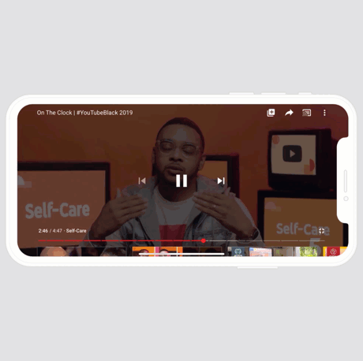

The design layout differs for both mobile and pc versions of the app. The mobile version is in portrait whilst the website is landscape due to the orientation of most smart phones being different to the landscape monitors of computers and laptops.

The website has a navigation bar on the left side whilst the mobile app has it on another screen that can be navigated from the icons at the bottom.

Both versions of YouTube have a preview of the videos, but they are accessed in different ways. On pc they are accessed by hovering over the thumbnail for a video with the mouse cursor and on mobile they are activated by having a video in the middle of your screen for a few seconds (shown in the screenshot).

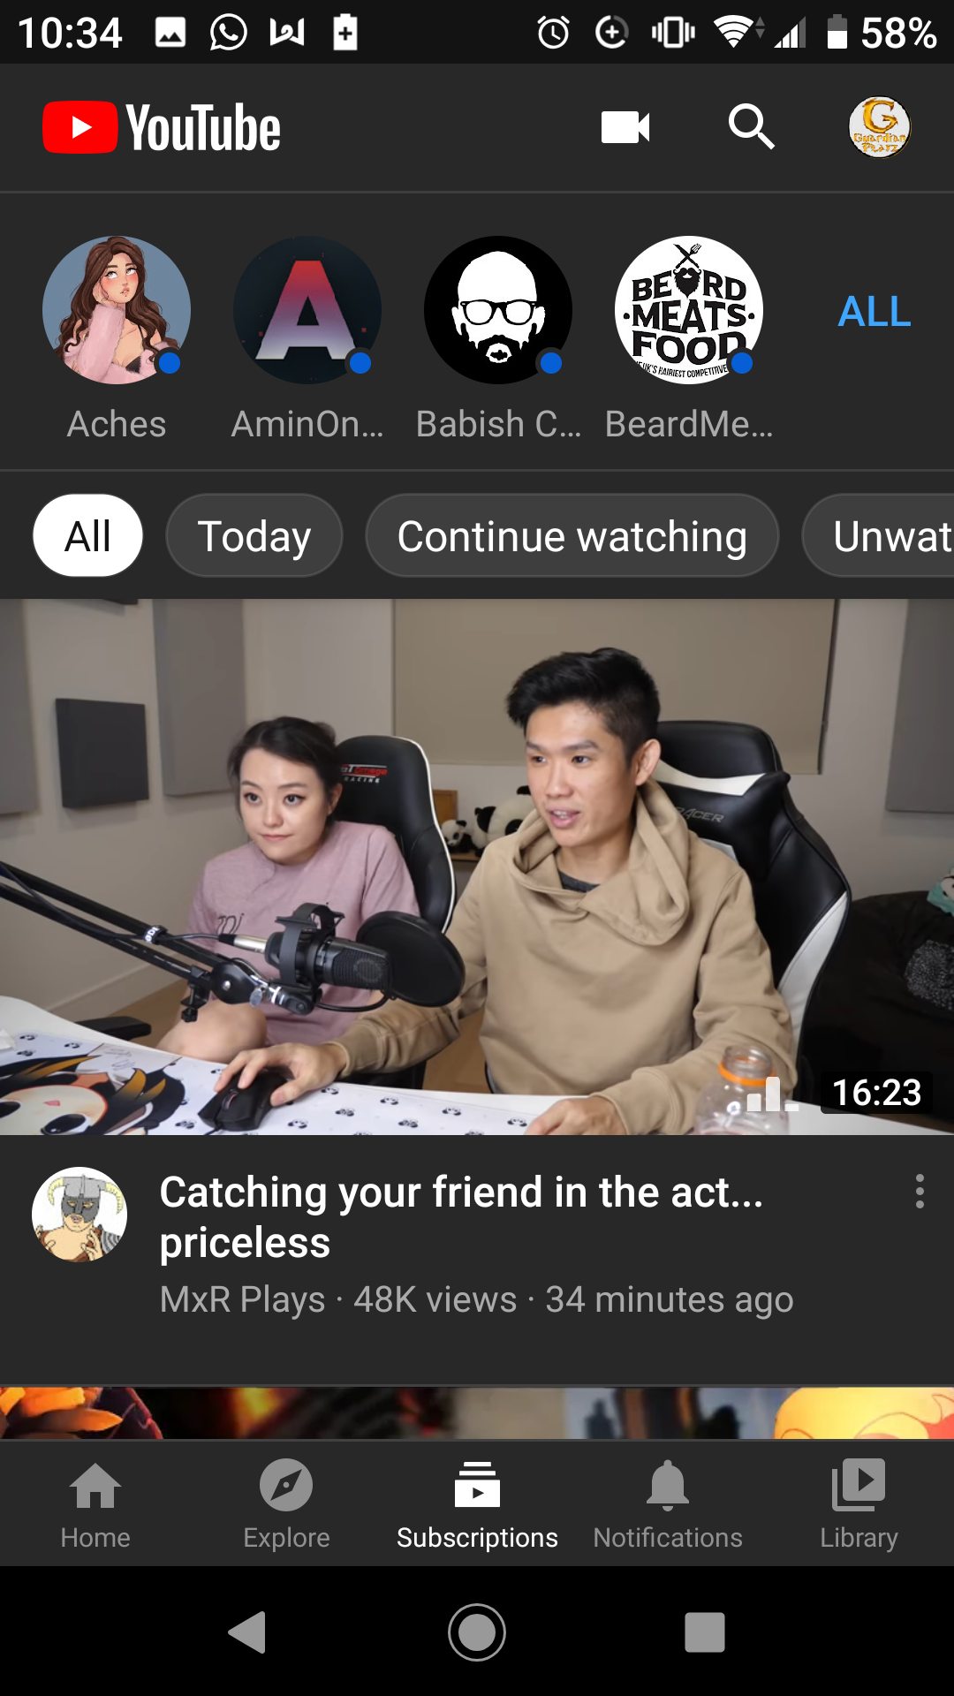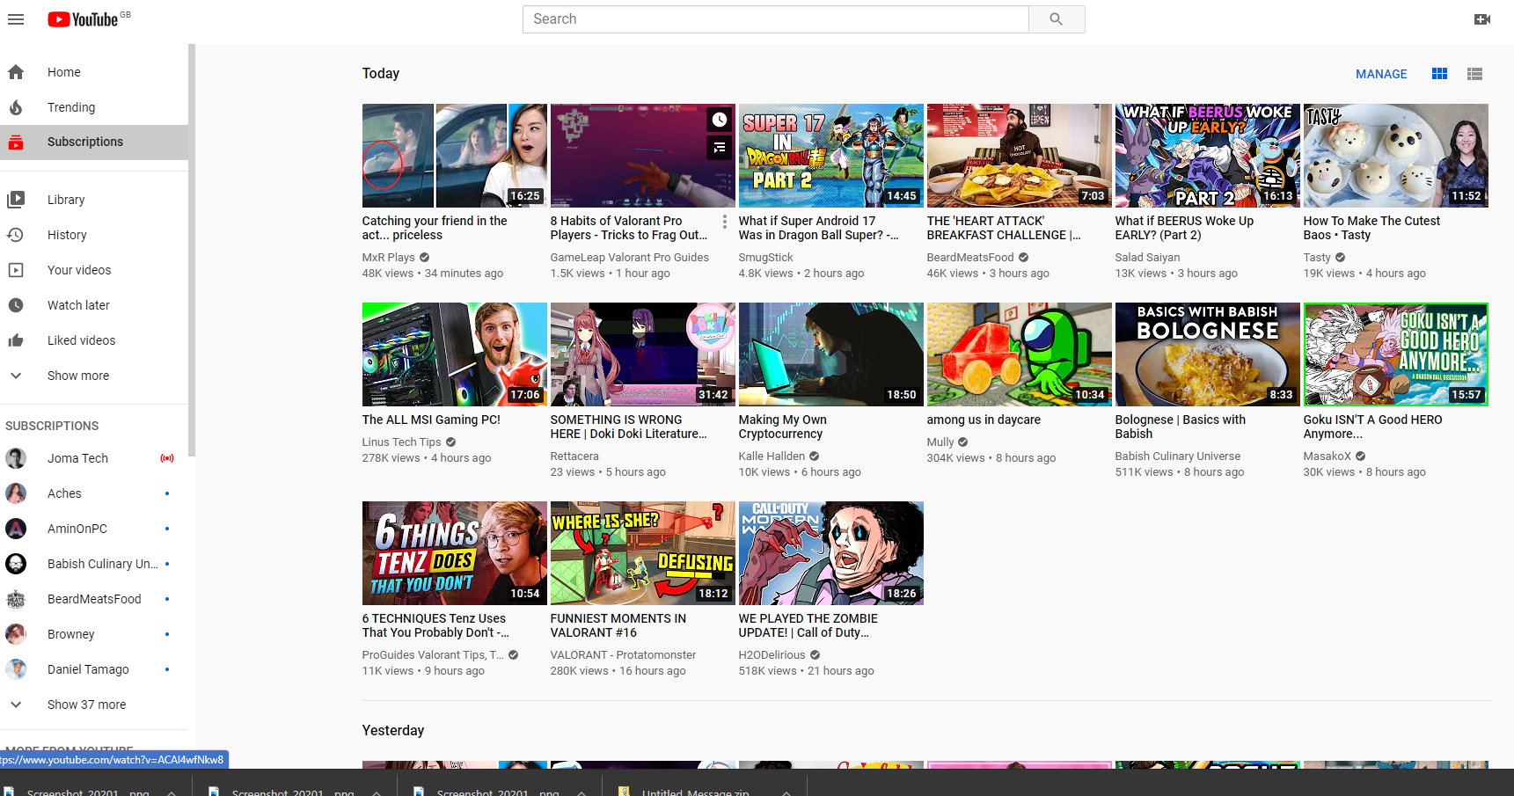

There is a ‘subscriptions’ page that can be accessed through the navigation bar on both the website and mobile app of YouTube. They both show the recent uploads from channels that you are subscribed to but do it in slightly different ways. The mobile version shows 1 or 2 at a time due to screen space limitations and has some of your subscriptions at the top of the screen. The website version has more screen space to use and as such shows more videos, the subscriptions on the website is built into the navigation bar on the left side and is out of the way.

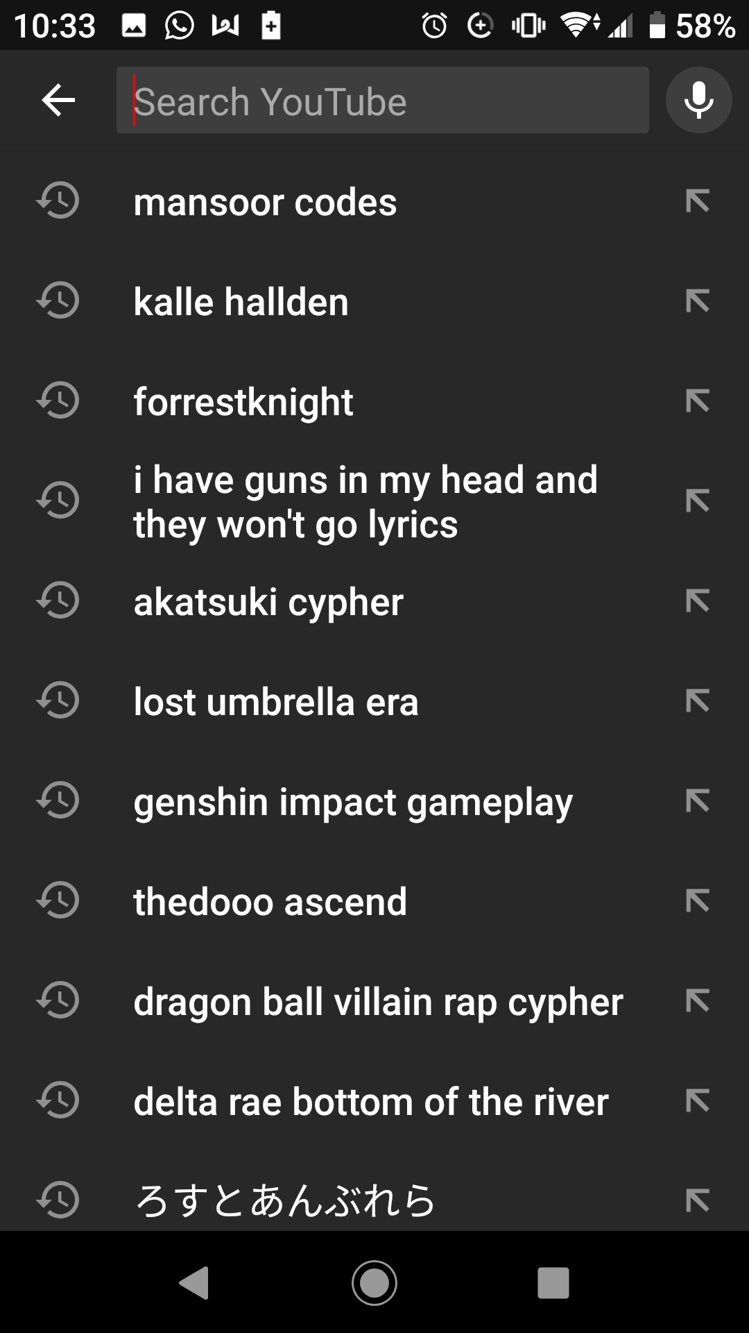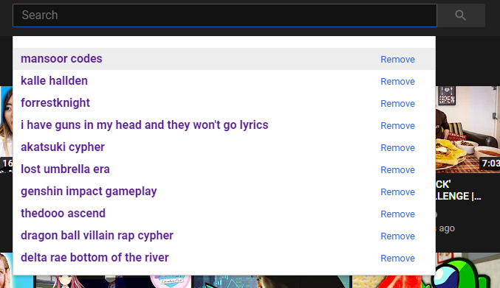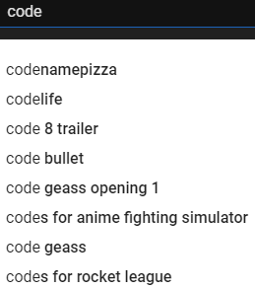

The search bar on both the mobile app and the website version of YouTube work exactly the same, they show your recent searches and when you type something into the search bar, they come up with suggestions for what you may be trying to find. The differences here are only in the graphical appearance and the number of previous searches shown, on the mobile app you can also scroll down to look at even more previous searches.

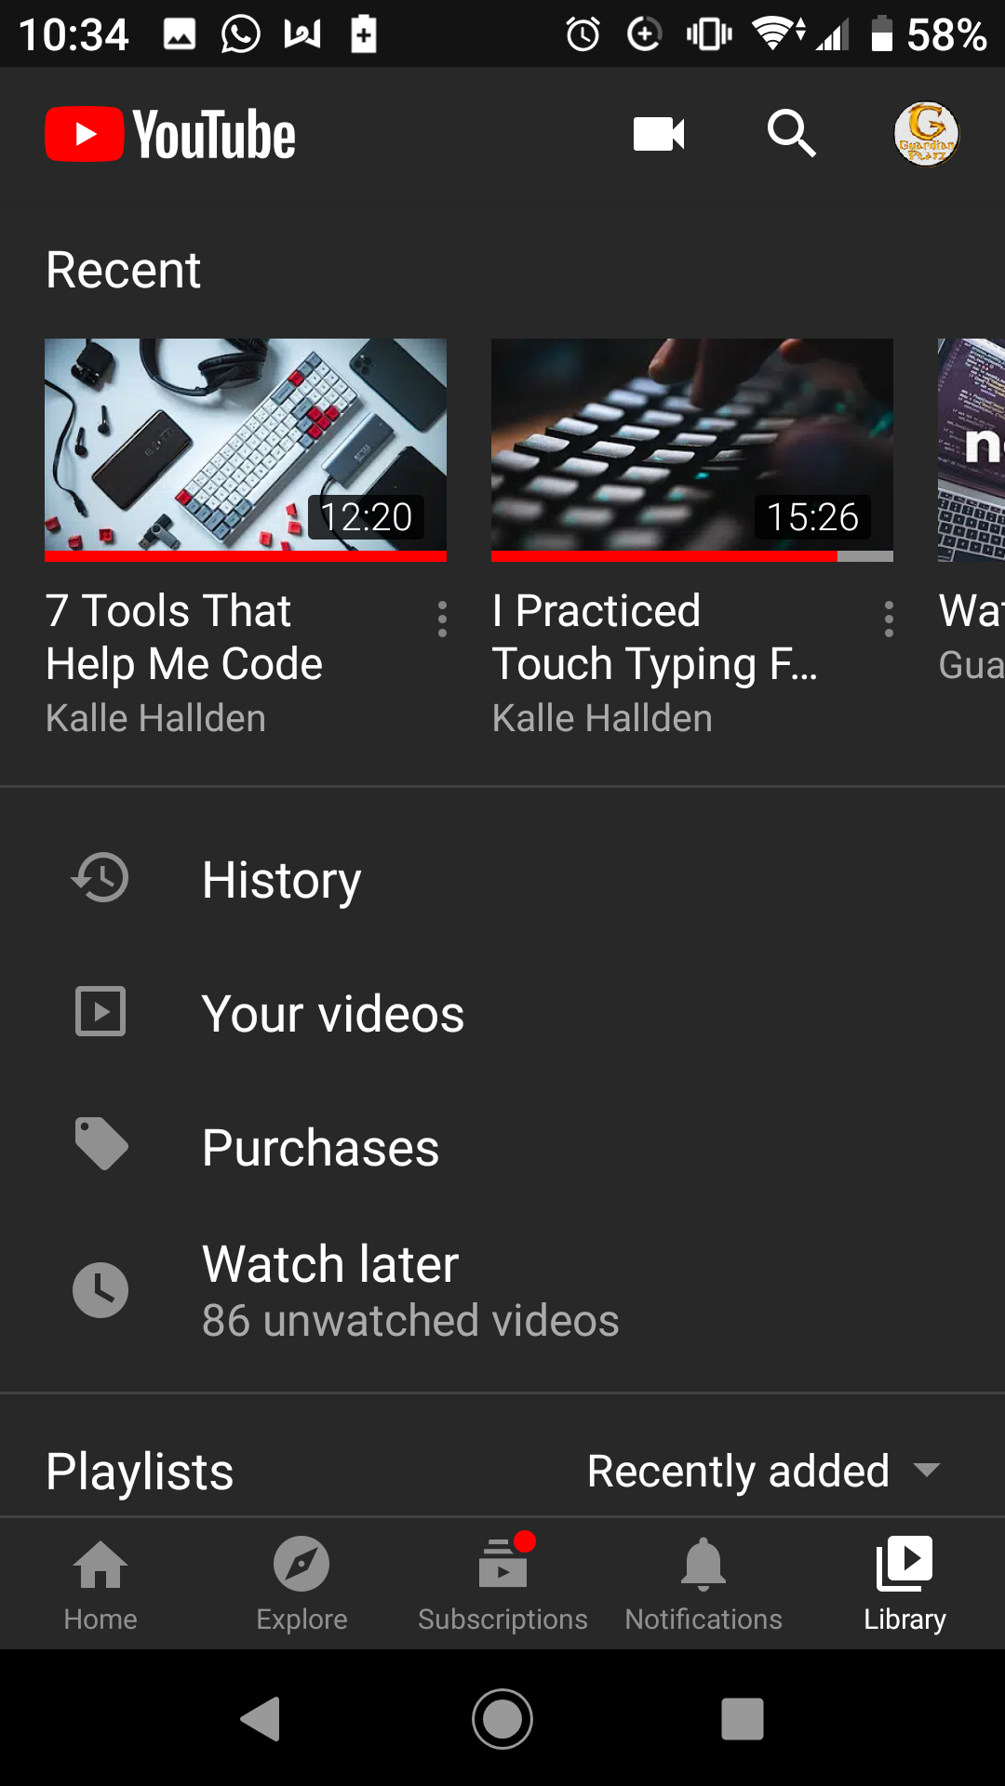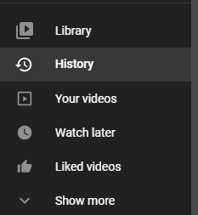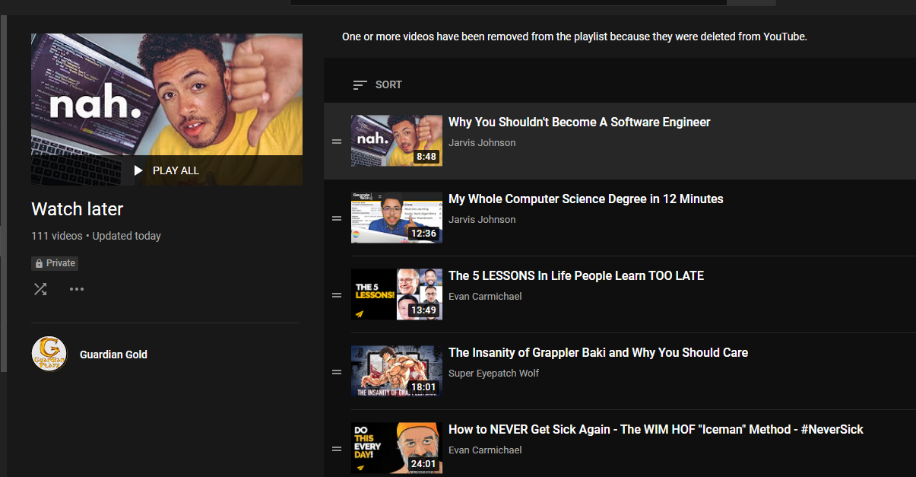

The ‘Library’ and other functions on the websites navigation bar such as ‘History’, ‘Your videos’, ‘Watch later’ and ‘Liked videos’ can be accessed on the mobile app by clicking on the ‘library’ icon on the left side of the navigation bar at the bottom of the screen. This allows you to check videos you have marked as ‘liked’ or added into your ‘watch later’ playlist as well as view your own uploads and your extensive watch history.

# YouTube is a very good app that effectively makes use of its features very well and does its purpose. It does not have a primary platform as its users are spread across all platforms. The design of YouTube is very eye catching and is aesthetically pleasing regardless on the theme you are using, both light and dark mode are very appealing. YouTube is very easy to use for both content creators and viewers alike, looking for videos to watch is as simple as typing in their name and clicking on them. Uploading videos is simple, you just click on the create icon on the top right and upload a video file then give it a name and description.



YouTube also has very easy to use video controls such as pausing the video, controlling the volume or even muting it, timeline control to go to any point of the video and watch the video or going full screen. These are the general video controls but there can be additional ones such as controlling the play speed to watch the video in slow motion or in fast motion, adding subtitles to the video.

A positive point of YouTube is how easy it is to use for viewing and for uploading videos so that people can enjoy them, becoming a content creator is a dream of many and being paid for it as a full-time job is even more so.

Another pro is the marketing benefits you gain from having adverts on your videos, these allow you to be paid for the amount of views you get and if people click on the ads instead of skipping. Some ads can be skipped in 5 seconds and others are unskippable for a full 30 seconds, which is not ideal as unskippable ads are not liked and can be quite annoying.

Another pro is that it is the biggest hub of videos of all kinds of content including but not limited to education, entertainment, music, gaming and more, the large userbase and has been acquired overtime due to the good reputation YouTube has built up over the past decade due to having loyal users who frequently upload quality content and even due to some videos going viral.

A negative point of YouTube is that there is a lack of privacy, once a video is out there it can be seen by all. You can put videos on private but then no one at all can view them, the main point of uploading videos is for others to find and watch them. If you only want certain people to watch videos you can have the on unlisted and send them the link so that they can only watch it through the link.

Another con is the inappropriate content you could find, from things like videos of hate speech that you don’t want to see or downright rude comments on videos, YouTube’s algorithm for searching is not very good and you can find content that you don’t want to by accident, also although there is a feature for content creators to disable the comment section there is no limit on what users can comment on videos that have it enabled so unless the creator reads every single comment and removes the ones that are offensive in some way or other the comments remain unfiltered.

Another con is the copyright infringement that can take down your videos if you use other people's content, be it music or photos. YouTube claims to take this seriously but there are still many channels out there that post plagiarised content without feeling the repercussions of it.

In my opinion I believe that the YouTube website much better than the mobile version as it has much more screen space, a larger screen is best for an optimal viewing experience when watching videos. There are more videos showed in suggestions on the homepage as there is more space to show it on and the small screen of a mobile device doesn’t have this luxury. The mobile version has less space and requires you to scroll through a list of videos 1 by one which is more time consuming. However, the mobile version has the advantage of being more portable as regardless of where you go you can watch videos. I still stand by my preference of using the website on a computer or laptop as it gives a much better viewing experience.

**Evaluation**

Overall YouTube effectively achieves its purpose on all platforms as it is designed very well by a team of experts and is eye catching but not too vibrant to the point that it becomes an eyesore. It has a high degree of usability and a low learning curve as it is so easy to navigate and use that it doesn’t require a tutorial. It has quite a lot of very good features that make the viewing experience optimal by giving you easy access to everything the site has to offer at only a few clicks, one of these features is the ‘add to watch later’ button just underneath your video. This button allows you to add a video to a playlist for later viewing and can help make your experience very good when you desire to watch a video but do not currently have enough time to do so. It is a very reliable app with an excellent reputation and as such is not viewed with suspicion by newcomers, its reliability is proven with the high degree of similarity through different versions of the app.

It effectively meets the needs of its users by generally having a similar layout and theme throughout the different versions of its app on different platforms so that it can be properly navigated without problem, this is because of how clear the app layout is and the generally similar features and functions. The Android and iOS version of the app is much more usable on the go compared to the website as it is optimised to be able to be navigated with the least amount of clicks or gestures to save time, this is a very efficient way of designing the mobile app. The usability of YouTube meets the needs of the users by being easy enough to understand without any explicit instructions by using generalised icons that can be related to their functions such as a pause button icon to pause videos. The reliability of the app grants relief to the user as they do not need to worry about extremely explicit content such as drug use or sexual acts since that kind of content is age restricted or in some cases even downright banned. One feature of the app is that you can see an unlimited amount of your previous searches in the search bar by just scrolling down while on the website you would need to use the ‘view search history’ option. Another feature of YouTube that could possibly be improved is the fact that you need to manually remove videos from your ‘watch later’ list once watching them or else they will just stay there; it would be a good improvement if they were automatically removed one watched.

It effectively makes use of the technology on hand on all versions of the app by allowing touch screen input to navigate the app with taps, swipes and pinches on mobile devices and using a mouse and keyboard on computer, it even allows a controller to be used on console. YouTube also uses some new technologies such as 4k video quality and 360 degrees videos that make use of motion sensing through the phone's gyroscope. Another way YouTube makes use of technology is by saving your last watch time on a video across all of your devices so you can pick up the last video you watched right where you left it, even if you are on another device.

YouTube and Instagram are both visual based social media apps that are more focused on media than text, YouTube focuses on videos and Instagram focuses on both videos and photos but more so on photos as its main focus.